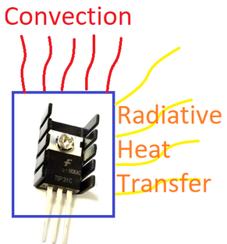A finned heat sink is attached to the transistor to increase the surface area and increase the heat removal both by convective and radiative heat transfer. A temperature sensor is attached to the transistor to monitor the temperature.

A lumped parameter energy balance model of the Temperature Control Lab (TCLab) assumes that there is one uniform temperature in the control volume and that all heat loss is through radiative and convective heat transfer.

$$mc_{p}\frac{dT}{dt}=UA\left(T_{a}-T\right)+εσA\left(T_{∞}^{4}-T^{4}\right)+αQ$$

Where:

$UA\left(T_{a}-T\right)$: Heat lost by convection, in Watts. Newton’s law of cooling.

$εσA\left(T_{∞}^{4}-T^{4}\right)$: Heat lost by radiative heat transfer, in Watts. Grey body model.

$αQ$: Heat generated by the heater.

and:

$m$: Mass of the transistor/heat sink $\left[kg\right]$

$c_{p}$: Specific heat capacity $\left[\frac{J}{kg∙°K}\right]$

$U$: Heat transfer coefficient $\left[\frac{W}{m^{2}∙°K}\right]$

$A$: Heat transfer surface area $\left[m^{2}\right]$

$T_{a}=T_{∞}$: Ambient temperature $\left[°K\right]$

$T$: Temperature of the object’s surface $\left[°K\right]$

$ε$: Emissivity factor [no units]

$σ$: Stefan–Boltzmann constant (5.67×10−8)

: The relationship between the heater and the power output $\left[\frac{W}{\%}\right]$

Notice that both left-hand-side and right-hand-side have units of Watts.